
Cooperative
Extension Service
Ballard County
110 Broadway, PO Box 237
LaCenter Ky 42056
(270)665-9118
Fax: (270) 665-5241
www.ca.uky.edu/ces
pjerrell@uky.edu
Newsletter


June/July 2023

CALENDAR OF EVENTS
All meetings are at the Ballard County Extension office, 110 Broadway LaCenter unless otherwise noted

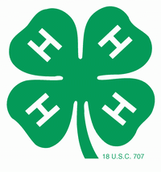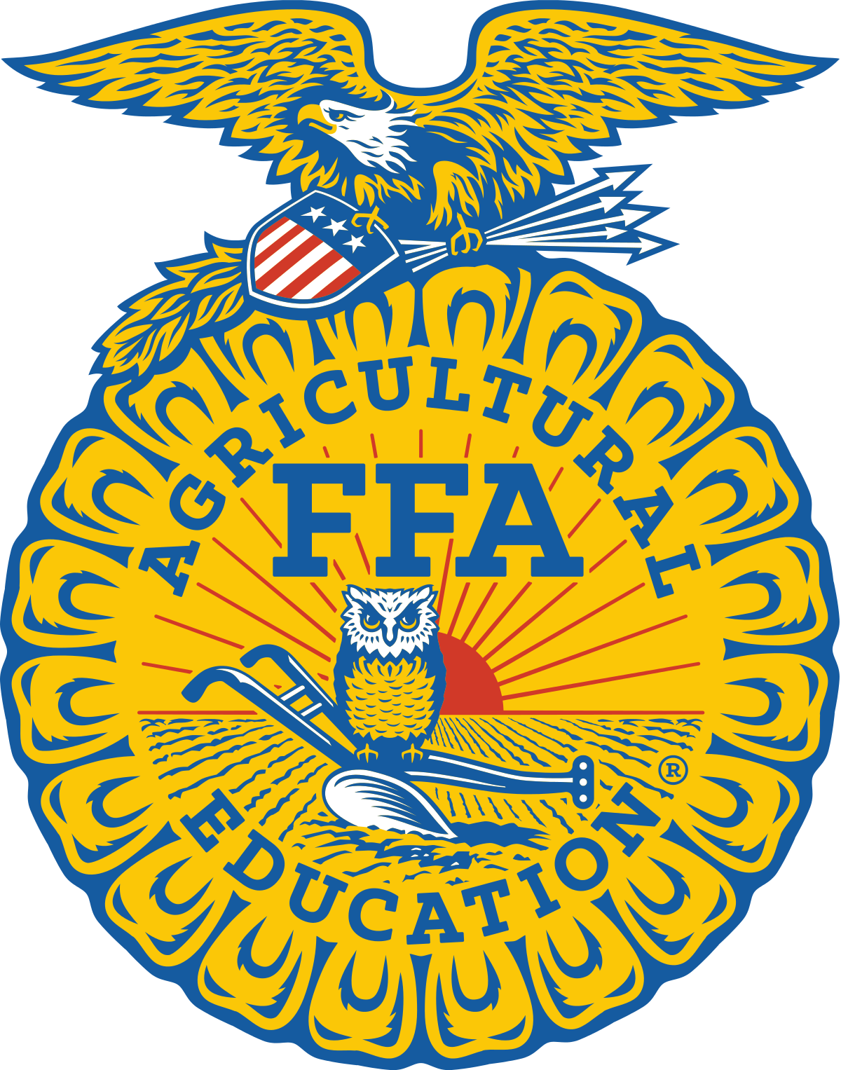
Kids Helping Kids

Silent Auction to benefit
Emily Dulworth
and
Family of Hudson Pace
July 8
Fairgrounds

May 31 | Project Day – Horticulture/Home Env. 10am-noon  Call to sign up, 2706659118
June 5 | 4-H Council, 4:30pm, Conference Room
June 6 (Tuesday) | Cooking Club 1PM-3PM
June 9 | Camper Lice Check, BCES, 7:30am-noon
June 12-15 | 4-H Camp, Dawson Springs
June 13-16 | 4-H Teen Conference, UK Campus, Lexington
June 20 | Art Club, 10am – noon
June 21 | Project Day Polymer Clay 10-noon  Call to sign up, 2706659118
July 8 | Fair Tractor Pull and  Kids Helping Kids Silent Auction, Fairgrounds  5:30-8:30pm  BMHS FFA Alumni Raffle Drawing 8pm
July 11-12 | 4-H Fair Entries (see fair book for details)
July 12 | 4-H Fair Entries judged
July 12-14 | Fair entries displayed at 4-H Office
July 15 or 17 | Pick up Fair Entries (see fair book for exact times)
August 5 | Bomber Bash
August TBA | Kentucky State Fair Trip, TBA

Shooting Sports

We are going to have a MUM fundraiser this fall. In order to get ready we will be preparing pots at 9:30am on Saturday, May 20. Watch for details from Roxie. Thank you to Derrick and Erika Damron for this opportunity. Be watching this August for advertising for on-site sales

Teen Scene

Mark your calendars for Monday, September 11, for a get together with dancing, games and food at The Studio at Woods and Co on Old Cairo Road.

Lacey Burnley will be going to 4-H Teen Conference June 13-16, on UK Campus in Lexington.

Congratulations!

Landyn Haney, Sophia Bourff and Harper Thompson competed at the first ever West 1 and West 2 Area Communications Event on May 2.Thank you to all the 4th grade for learning about speeches and Mrs. Richardson for leading them in the effort.

Molly Harris graduated May 19. She has been a 10 year member of 4-H.

4-H Camp

We will be going to 4-H Camp on June 12-15. We currently have 68 registered for camp. We are currently good on counselors, but if anyone would be willing to do a background check to be on standby for emergency, I would gladly get you signed up.

“Like” the Ballard County 4-H Facebook Page for pictures and announcements.

Released by:
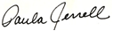
County Extension Agent For
4H/Youth Development
Fair

We are looking forward to having lots of exhibits at the fair this year. We will be giving $400 in premium money sponsored by the Ballard County Fair Board. If you have made items or have done some art work or like to cook or so many other activities, please come by the 4-H Office and pick up a 4-H Fair Exhibit Book. Or you can call and we can email it to you. We have so many categories to choose from.

Check out the project days in the calendar. Like and Follow the Ballard County 4-H Facebook Page for other possible announcements.

Kids Helping Kids

4-H, FFA, Ballard County 4-H Council and Ballard Memorial FFA Alumni have joined forces to put on an amazing silent auction to benefit Emily Dulworth and the Family of Hudson Pace. We are hosting it in conjunction with the Ballard County Fair Tractor Pull on Saturday, July 8. The silent auction will take place between 5:30 and 8:30pm at the fairgrounds. Come see us and support these Ballard County families. #noonefightsalone

There will also be a Raffle through FFA Alumni. Raffle bundle donated by Hutson Ag. Flyer is included in this email.



