September 9, 2024

Dear Ballard County 4-H Leadership Ballard Donors and Potential Donors:

The Ballard County 4-H Council are Ballard is happy to announce that we are continuing the Leadership Ballard Class in the middle school with twenty-eight students. There was an application process this year with teacher reference checklist. The committee felt that all those selected were deserving of this program. We will be doing leadership and team building lessons, a manners and etiquette lesson and then taking three field trips in the spring including another trip to Frankfort, Kentucky. On the Frankfort trip we will also take 4-H Middle School Leadership Club members and adult chaperones.

I have done some price checking for a proposed budget. The cost of the charter bus will be approximately $6,500. We also will have two local field trips by school bus. We will have a luncheon for participants and sponsors at the UK Extension Office in the spring and have ordered polo shirts for participants. There will be some fees in Frankfort as well. We are looking at a total of approximately $10,000 total. We kindly request your consideration of a sponsorship. We welcome amounts of $50 to $6,500 or any amount you feel your business could sponsor. Recognition for sponsorship will be done by including the sponsoring businesses and organizations in any news releases, social media, participating in the spring luncheon and by invitation to our yearly 4-H Banquet.

Thank you for your consideration of this sponsorship request. We are committed to offering quality programming and developing life skills with memorable opportunities. It is a great opportunity for the youth of Ballard County. We now have former Leadership Ballard participants involved in the planning and teaching process and many in wonderful positions in the community. If you choose to sponsor, please complete the enclosed Leadership Ballard Sponsorship Form. We would like to have your sponsorships or pledge for sponsorship by November 1, 2024. If you have any questions, please call me at 270-665-9118, or email [pjerrell@uky.edu](mailto:pjerrell@uky.edu). If you need to reach me on my cell, it is 270-559-3392.

Sincerely,

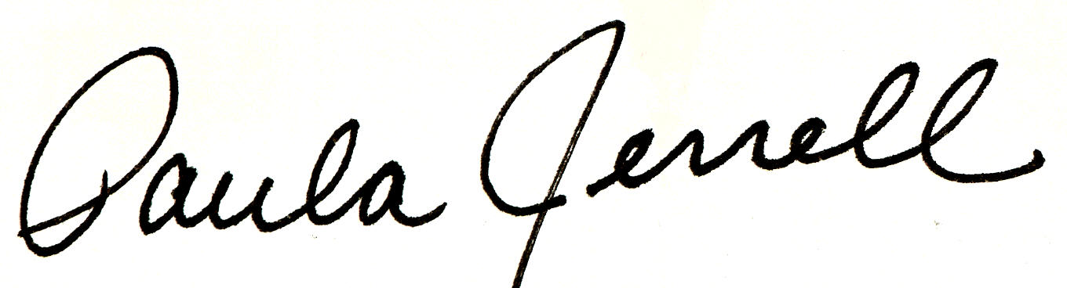

Paula Jerrell

Ballard County Extension Agent

For 4H Youth Development

**Leadership Ballard 2025 Sponsorship Form**

*Please complete this form. It helps us ensure we have the correct information for future contact and recognition.*

We/I agree to sponsor the 2024\25 4-H Leadership Ballard Program in the amount of: $ ___________.

Business, Individual or Organization: _______________________________________________

Contact Person: ________________________________________________________________

Mailing Address: _______________________________________________________________

E-mail Address: _______________________________________________________________

Phone #: _______________________________

Business or Organization’s name as it should appear in any news releases or other print:

Please send an electronic copy of any logo that should be used in the event of the opportunity to use a logo.

Leadership Ballard sponsorship monies are designated for the 4-H Leadership Ballard programs only.

Please make checks payable to:

Ballard County 4-H Council

For: 4-H Leadership Ballard

And send to:

Ballard County 4-H Council

P.O. Box 237

LaCenter, KY 42056

***Funds/Pledges need to be secured by November 1, 2024.***

**If you need a W9, we can do that. Please contact me directly at 2705593392 or** [**pjerrell@uky.edu**](mailto:pjerrell@uky.edu) **for more information on that.**