

January 29, 2024

To: Potential 2024 4-H Campers

From: Paula Jerrell
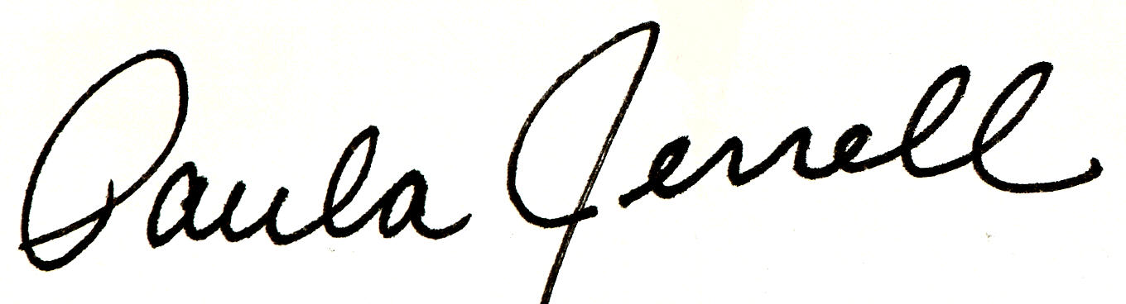
Ballard County Extension Agent
For 4-H Youth Development

Re: 4-H Camp
July 8-11, 2024

Enclosed/attached/posted are the forms that you need to sign up for 4-H Camp. The cost is $320. Five payments of $64.00 may be done rather than full payment at time of registration. Payments are due with registration as follows: February 15, March 15, April 15, and May 15. Payments are due in full by May 31st. There will be some scholarships available and we offer one scholarship for each camper who also has an adult family member to attend as a camp counselor. For a scholarship, please contact our office directly, 270-665-9118, 110 Broadway, La Center, KY.

As always, we cannot confirm any campers until our ratio is met for adult and teen leaders. We have 2 girls cabins (44 female camper spots) and 1 ½ boys cabins (16 boy camper spots). Therefore we will need 8 female counselors and 5 male counselors.

